What is Java Servlet?
Java Servlets are the Java programs that run on the Java-enabled web server or application server. They are used to handle the request obtained from the web server, process the request, produce the response, and then send a response back to the web server.

Servlet – Flow of Execution
Servlets provide a way to communicate with client requests and generate dynamic responses based on the request-response programming model. For writing Servlets, Java Servlet API provides interfaces and classes in javax.servlet and javax.servlet.http packages.

Flow of Execution of Servlets
In the execution of a servlet for the provided client request, the servlet container plays a crucial role in the Servlet life cycle.
Servlet container:
It is a web container that is part of a web server that interacts with the Java Servlets. Servlet container is responsible for
- Managing the lifecycle of servlets
- Creating servlet object, request, and response objects
- Mapping a URL to a particular servlet
- Ensuring that the URL requester has the correct access rights
Servlet Program:
To understand the flow of execution of the servlet, we will create a simple web application to display the hello message in the client browser. Create the following files as shown in below package directory structure.
index.html:
Create the below form to take the user name as input from the client browser.
- HTML
<html>
<head>

<title>Home</title>
</head>
<body>
<form action="hello" method="post">

Enter your name and click on submit:
<input type="text" name="name" />
<input type="submit" />

</form>
</body>
</html>
HelloServlet.java:
Create below servlet to accept the client request, process it, and generate the response.
- Java
package com;

import java.io.IOException;
import java.io.PrintWriter;
import javax.servlet.ServletException;
import javax.servlet.http.HttpServlet;
import javax.servlet.http.HttpServletRequest;
import javax.servlet.http.HttpServletResponse;

public class HelloServlet extends HttpServlet {

protected void doPost(HttpServletRequest request,
HttpServletResponse response)
throws ServletException, IOException
{

// Get the client entered data from request object
String name = request.getParameter("name");

// set the response content type
response.setContentType("text/html");
PrintWriter out = response.getWriter();

// Print hello message to the client browser in
// response object
out.println("<h3>Hello " + name + "!!</h3>");
out.close();
}
}
web.xml:
Create deployment descriptor – web.xml file to mention the welcome file and to map the URL to the Servlet class.
- XML
<web-app >
<welcome-file-list>
<welcome-file>index.html</welcome-file>
</welcome-file-list>
<servlet>
<servlet-name>MyHelloServlet</servlet-name>
<servlet-class>HelloServlet</servlet-class>
</servlet>
<servlet-mapping>
<servlet-name>MyHelloServlet</servlet-name>
<url-pattern>/hello</url-pattern>
</servlet-mapping>
</web-app>
At server side:
- Servlet container is available in the Main server and the web application is deployed into a servlet container.
- Inside the container, we have below folder structure.
- Web application – In this example, “ServletFlow”
- Inside that WEB-INF folder – we have URL mapping to the servlet name.
- Inside WEB-INF, web.xml file and classes folder to maintain .class file of “HelloServlet.java”
At client side:
- A browser will be available to send the client data in HTTP request and receive the HTTP response from the server.
- The protocol will establish a virtual socket connection between client and server based on IP address and port number.

When we start the server, the job of the servlet container is to
- Recognize all the web applications
- Deploying those web applications and
- Prepare a separate object for each application. This object is “servletContext” object.
While deploying web applications,
- The container will recognize the web.xml file under the WEB-INF folder.
- After identifying the web.xml file, the container will perform web.xml file loading, parsing, and reading the contents of it.
- If any application-level data like display names or context parameters are available in the web.xml file, the container will take that application data and store it in “servletContext” object. This data is managed by a servlet context object.

Now, the container will identify the welcome file page to display on the client browser based on the “welcome file list” mentioned in the “web.xml” file. Here, we specified, “index.html” as a welcome file. So, it displays that HTML page to the browser. URL: http://localhost:8081/ServletFlow/
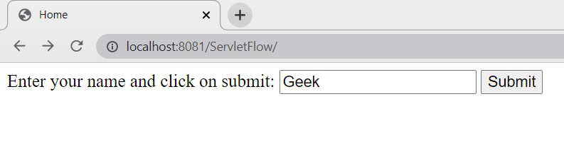
index.html
Once we enter the name and click on submit, then a request will come to protocol with the data entered by the client.
The protocol will prepare request format, it has 2 parts, Request header, and Request body. The actual data entered in the user form will store in the Request body in form of request parameters.
- The protocol will carry this Request format to the main server.
- Then the server will check whether the request is valid or invalid.
- If it is valid, it will forward that request to the servlet container.
- Now, the container will identify what is the application name and resource name to execute. Once the container identifies the servlet .class file, the life cycle of the servlet will start.

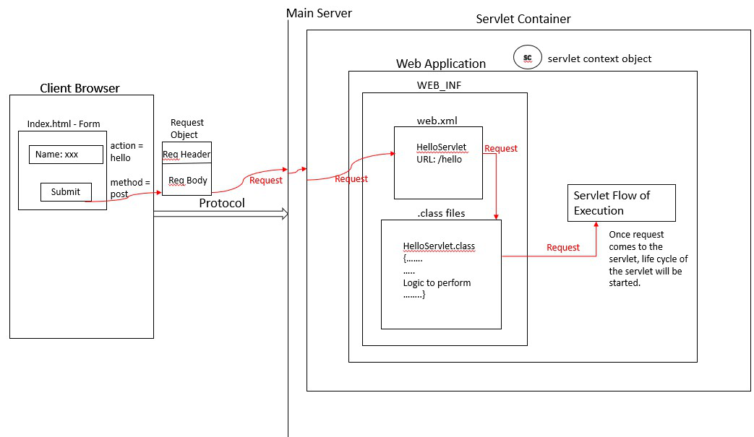
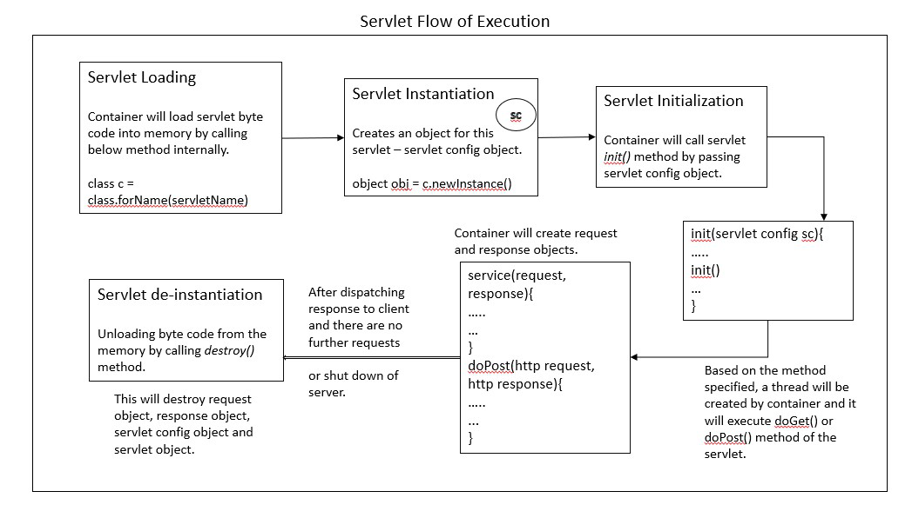
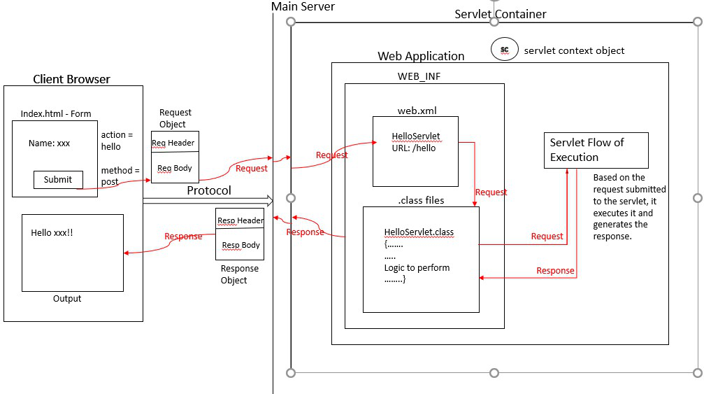
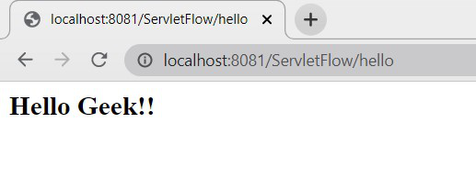
Output
Java Servlets don’t have a main() method. It’s the job of Servlet Container for instantiating the servlet or creating a new thread to handle the request and response objects. To process multiple requests in a single servlet the container creates multiple threads.

